**Experiment-9 Study of DNS server**

ECP316 (Communication Networks)

**Aim:** To study DNS server using Cisco Packet Tracer.

**Tools Used:** Cisco Packet Tracer

**Theory:**

A DNS server converts easily readable domain names (like 'www.example.com') into numerical IP addresses (like '192.0.2.1'). It handles name resolution, ensuring users reach the correct website by communicating with multiple DNS servers when necessary. There are two primary types:

1. **Recursive DNS servers** – Retrieve IP addresses by querying other servers.
2. **Authoritative DNS servers** – Maintain the official DNS records for domains.

This process takes place in mere milliseconds, often utilizing caching to speed up responses. DNS plays a crucial role in linking users to websites across the internet.

**Procedure:**

1. Consider a PC, server and switch connecting them.
2. Assign static addressing to server and PC and configure server.
3. Then configure HTTP service and enable the DNS server in the services.
4. Go to the web browser of the PC and enter the web address.
5. Now if I give some name to the PC and want to recognize the PC by that name then I can do it via DNS. Add one more PC. Configure it.
6. Now open the command prompt of the new PC and try to ping the first PC by its name. You will get the message request timed out.
7. Now again go to the services tab of the server. In the DNS service, add the name and address of the first PC and save it.
8. Now ping the first PC by its name through the command prompt of the second PC. Ping xyz. Now it will be accessible.

**Connections:**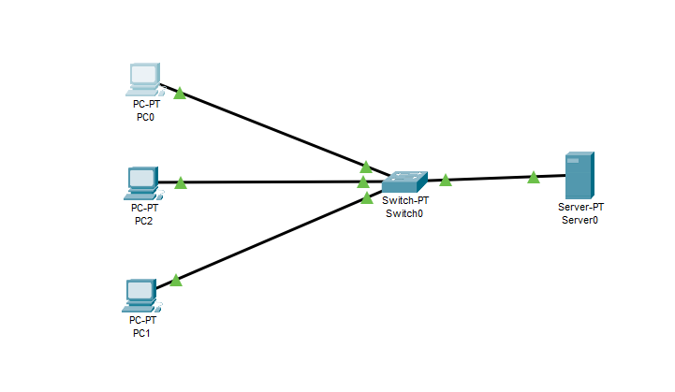

**Assigned IPs to PC and Server:**

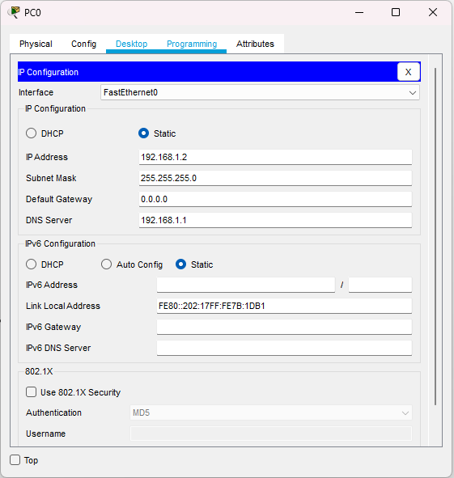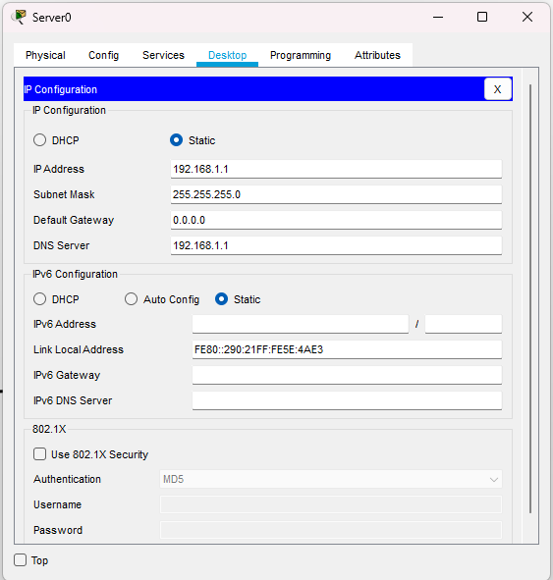

**Ping Test on PC and DNS Setup:**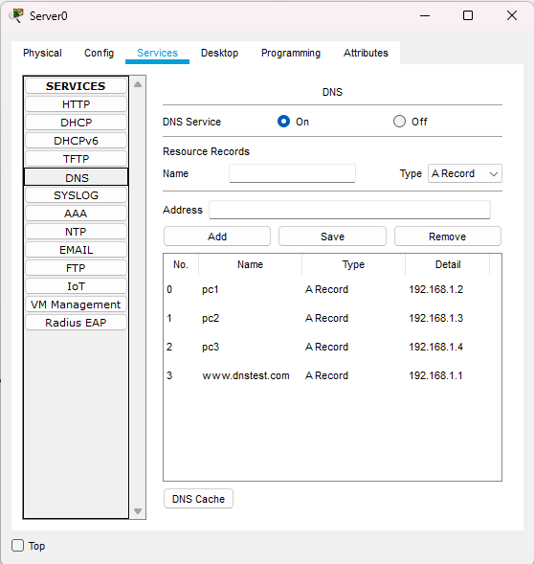

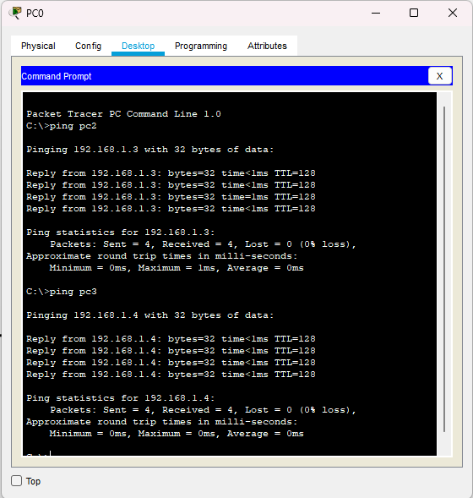

**HTTP setup:**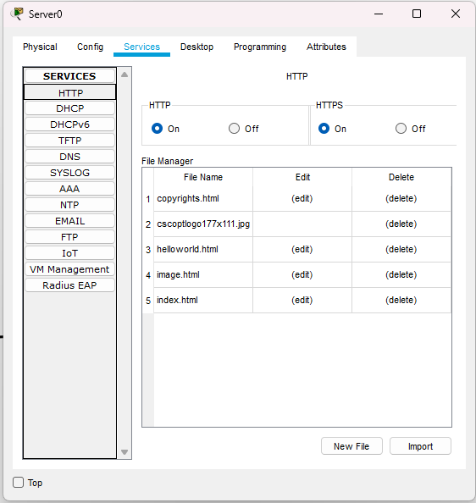



**Output on PC:**

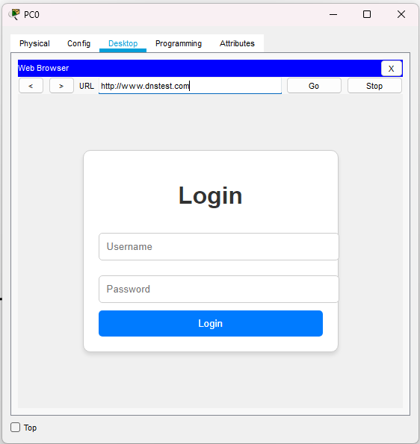

**Result:**

The experiment demonstrated the efficient translation of domain names into IP addresses through DNS servers. Recursive DNS servers successfully retrieved IP addresses by querying authoritative servers, which accurately provided stored records.

The process was rapid, typically completing within milliseconds, with caching significantly improving response times and ensuring seamless internet connectivity.

**Conclusion:**

1. **Efficient Name Resolution** – DNS servers effectively translate domain names into IP addresses, enabling seamless internet access.
2. **Role of Recursive and Authoritative Servers** – Recursive servers fetch data from authoritative servers, ensuring accurate resolution.
3. **Speed and Performance** – The DNS process occurs within milliseconds, minimizing delays.
4. **Caching Enhances Efficiency** – Cached responses reduce query time and server load.
5. **Essential for Internet Connectivity** – DNS is a fundamental system for accessing websites and online services.